EPHESIANS 2
THE GIFT

Ephesians 2:1 And you He made alive, who were dead in trespasses and sins,

- “Trespasses” are deliberate iniquities – disobeying God.
- “Sins” means missing the mark. You tried; you missed. You sinned.
  - Think: Target practice.
- Though challenging God’s authority as a trespasser is worse than missing the mark, both of these failures have the same effect. They condemn you.
- SO… from spiritual death to eternal life, GOD made us alive… But Paul reminds us of our former condition…

2 in which you once walked (Meandered) according to the course of this world,
- Chuck Smith says to think of how women meander through a mall… Men can walk the mall in minutes…
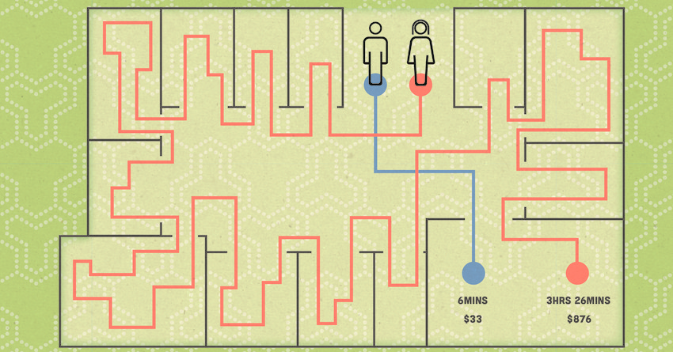

THE POINT… We once meandered through life…
…according to the prince of the power of the air, (Satan) the spirit who now works in the sons of disobedience, 3 among whom also we all once conducted ourselves in the lusts of our flesh, fulfilling the desires of the flesh and of the mind, and were by nature children of wrath, just as the others.

- Now, don’t worry… WE ARE going to heights here in chapter two, but first the Apostle is darkening the background upon which he will paint a glorious masterpiece.
- Think: Thomas Kinkaid… “The Painter of Light.”
- Let me ask you… Do you feel the world going in the wrong direction, spiritually? Sometimes we say, “That is just SO dark…” Right?
- Here comes the light and the height…

4 But God, who is rich in mercy, because of His great love with which He loved us, 5 even when we were dead in trespasses, made us alive together with Christ (by grace you have been saved),

- I love the song by Big Daddy Weave about this verse…
Alive by Big Daddy Weave
- I was dead in my transgressions, Wandering in sin
I went searching for redemption, Down a road that had no end
- I was walking through the fire, I was living on the run
With my flesh lost in desire, I was drowning in the flood
- But God, rich in mercy, You came to save me, Now I'm alive
But God, strong and mighty, You reached down for me, So I could rise…
Now I'm alive

Romans 5:8 But God demonstrates His own love toward us, in that while we were still sinners, Christ died for us.

SO, HE MADE US SPIRITUALLY ALIVE…
6 and raised us up together, and made us sit together in the heavenly places in Christ Jesus, 7 that in the ages to come (After we die) He might show the exceeding riches of His grace in His kindness toward us in Christ Jesus.
- COURSON - Not only were we loved by the Lord, but we were lifted by Him when He raised us up together and made us sit with Him in heavenly places. In John 11, we see Lazarus raised from the dead. In John 12, we see him seated with Christ around the table. The same is true of you and me. We are not only made alive in Christ, but now we can come to His table. We can fellowship with Him, talk to Him, and learn from Him. Soon, we'll be in heaven, sitting at the ultimate banqueting table at the marriage feast of the Lamb. What a day that will be!
- How many of you “count down the days until your vacation?” Only two months Honey and we will be in the mountains…. 4 weeks Babe and we will be on the Cruise… ONLY 4 days until we’ll be camping… ONLY 12 more hours until we leave for the airport…
  - WHY do we do this countdown? It gives us hope…
  - Listen… We are close to the day when the Lord will come and take us home to be with Him. IT… IS… OUR… BLESSED HOPE!

Titus 2:13 looking for the blessed hope and glorious appearing of our great God and Savior Jesus Christ,
- Listen, weary Child of God… Hold on! He’s coming!
- He sent a gift ahead too…

THE GIFT
8 For by grace (Unearned favor) you have been saved through faith, and that not of yourselves; it is the gift of God, 9 not of works, lest anyone should boast.
- A bank teller told me this week that she was having a tough day… It was hot out and she didn’t like hot days… She then joked, “That’s why I need to be good… I don’t like hot places…”
- A joke, yes… BUT… She was boasting of being good enough to get into heaven.
- DO NOT BOAST! Salvation is an undeserved, unearned, unmerited, and unwarranted gift. We are fortunate & blessed to be saved. BOAST IN THIS-
GOD AT WORK
10 For we are His workmanship, (NLT – Masterpiece) created in Christ Jesus for good works, which God prepared beforehand that we should walk in them.
- What do YOU have that YOU have made that is a masterpiece?
- Who has written a poem or song? Who has painted or taken and framed a picture? Who has made a piece of furniture? Sewn an article of clothing? Who has planted a beautiful garden? Who has filled their yard with birdseed houses? Who has recently painted your entire house?
  - Aren’t you SO proud of your masterpiece?
  - SO IS GOD PROUD OF YOU… Not because of us, but because of HIM!
Lord, thank You for making me Your masterpiece.

ONE IN CHRIST
11 Therefore remember that you, once Gentiles in the flesh—who are called Uncircumcision by what is called the Circumcision made in the flesh by hands—
- CEV - Don't forget that you are Gentiles. In fact, you used to be called "uncircumcised" by those who take pride in being circumcised.
12 that at that time you were without Christ, being aliens from the commonwealth of Israel and strangers from the covenants of promise, having no hope and without God in the world. SAD!

BUT GOD
13 But now in Christ Jesus you who once were far off have been brought near by the blood of Christ.

- We moved from dead to alive because of God’s work in us…
- 1 John 3:14 We know that we have passed from death to life, because we love the brethren. He who does not love his brother abides in death.

NO JESUS NO PEACE
14 For He Himself is our peace, who has made both one, and has broken down the middle wall of separation, (Hostility) 15 having abolished in His flesh the enmity, that is, the law of commandments contained in ordinances, so as to create in Himself one new man from the two, thus making peace, 16 and that He might reconcile them both to God in one body through the cross, thereby putting to death the enmity.

- In the early Church the hostility between people was their race.
- Aren’t you glad THAT has changed?
- The best answer to racial tension is Jesus!

17 And He came and preached peace to you who were afar off (Gentiles) and to those who were near. (Jews)18 For through Him (Jesus) we both (Jews and Gentiles) have access by one Spirit to the Father.
- GUZIK - Early Christians called themselves a “third race” or a “new race.” Early Christians recognized that they were not Jews, not Gentiles, but one new man embracing all who are in Jesus.
- What a lovely way of thinking differently about those who are different from you. Fellow citizens!
FELLOW CITIZENS
19 Now, therefore, you are no longer strangers and foreigners, but fellow citizens with the saints and members of the household (Family) of God, 20 having been built on the foundation of the apostles and prophets, Jesus Christ Himself being the chief cornerstone, 21 in whom the whole building, being fitted together, grows into a holy temple in the Lord, 22 in whom you also are being built together for a dwelling place of God in the Spirit.

We are under construction in the hands of the Lord, Beloved. We are being built together as a dwelling place of the Lord.

Have you noticed that WE are NOT a building? We are his body, the body of Christ, built together to honor and glorify Him!

