Philippians Introduction

The Apostle is sending what the Open Bible calls a thank you note to a group of believers in the city of Philippi - Philippi was named after Phillip, the Father of Alexander the great. It is in what is now Greece. Paul visited there on his second and third Missionary trips. Here is his second trip.

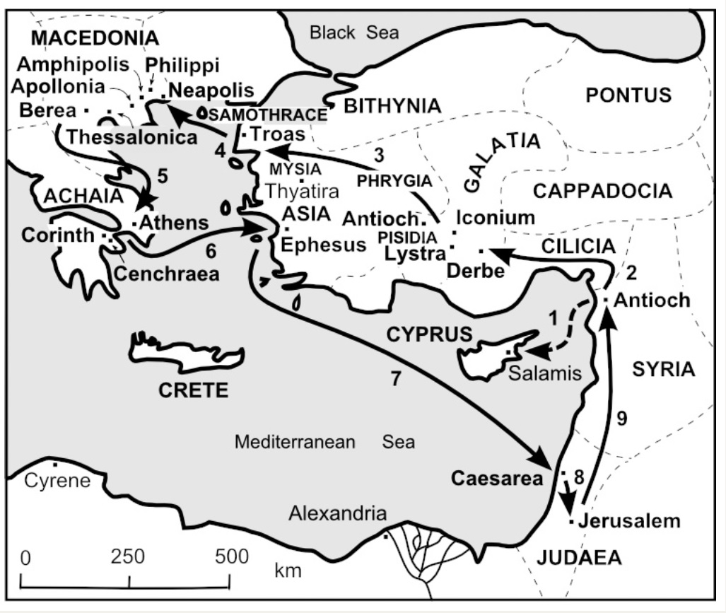

Philippi was a Roman military city and not a commercial center. Jews were rarer in Philippi than in commercial centers like Ephesus or Corinth. That explains why there was no synagogue there and why the churches growth was slower there.

But it does not account for the generosity of the Philippians. They were small in number but large in their support for the Apostle. On at least three occasions they came through with love offerings for Paul.

It was in Philippi that Paul and Silas were beaten, jailed, and listened to as they sang praise songs while locked up.

The Philippian jailor was saved as a result. Paul founded this Church on his second missionary visit and was closer to the Philippians than any other church he founded.

Ironically, Paul is in a Roman prison, the Mamertine prison, on death row as he pens this letter. Lynette and I got to visit his cell many years ago. It is worth the time if you get to Rome.

Key verses in Philippians:
- 1:6 - He who has begun a good work in you will be faithful to complete it...
- 1:21 - For to me, to live is Christ, and to die is gain.
- 2:10 - That at the name of Jesus every knee shall bow.
- 3:7 - But what things were gain to me, these things I have counted loss for Christ.
- 3:10 - That I may know Him and the power of His resurrection.
- 3:14 - I press toward the goal for the prize of the upward call of God in Christ Jesus.
- 4:4 - Rejoice in the Lord always. Again, I say, rejoice!
- 4:6 - Be anxious for nothing...
- 4:8 - Finally brethren, whatever things are true, noble, just, pure, lovely, of good report, of virtue, and praiseworthy - think on these things!
10. 4:13 - I can do all things through Christ who strengthens me.
11. 4:19 - And my God shall supply all your needs according to His riches in glory by Christ Jesus.

Philippians is the 50th book in the English Bible. It has 4 chapters, 104 verses, 2183 words... all of which we will study in the coming weeks.

Philippians is nick-named the Epistle of Joy. Even though in terrible circumstances the Apostle is indeed teaching the Philippian church and ours as well that Christianity is to be a joyful celebration of life and not a constant commemoration of past sorrows and suffering.

So, let's enjoy this letter as we listen in to a friend writing to a group of friends. Timothy is Paul’s scribe as the Apostle shares his heart…

CHAPTER 1

Philippians 1:1 Paul and Timothy, bondservants of Jesus Christ, to all the saints in Christ Jesus who are in Philippi, with the bishops (Overseers) and deacons: (Attendants)

- Did you notice that Paul DOES NOT defend his apostleship to the Philippians?
  - He didn’t need to. The Philippians were incredibly supportive of his calling.
- He addresses his letter to us – Did you notice that? “To ALL the saints…”
- Then he recognizes the “doers” – the Leaders as well as the serving saints.
- I thank God for our serving community.

2 Grace to you and peace from God our Father and the Lord Jesus Christ.
- CCSV, why grace… before peace? Without grace, there is no peace!

THANKSGIVING AND PRAYER
3 I thank my God upon every remembrance of you, 4 always in every prayer of mine making request for you all with joy,
- Paul smiled when he thought about the generous saints in Philippi. They were so loving and generous AND humble too. They were small but potent in their ministry.
- The Apostle loved seeing how God was working in the lives of the people he ministered to.
- Listen to him brag about the Philippians…

“I thank God…”
5 for your fellowship (koinonia) in the gospel from the first day until now, 6 being confident of this very thing, that He who has begun a good work in you will complete it until the day (return) of Jesus Christ;

- Koinonia was a relationship that was more that just church & missionary. It was a partnership.
- GUZIK - The idea is that the Philippians “partnered” with Paul in his spreading of the gospel through their friendship and financial support, and they did so from the first day until now. They didn’t wait to see if Paul was a “winner” before they supported him. They got behind Paul and his ministry early.
- And then this glorious promise- V6 that God will complete His work in us! That is a pretty nice guarantee, right?

PARTNERSHIP IN PERSECUTION
7 just as it is right for me to think this of you all, because I have you in my heart, inasmuch as both in my chains and in the defense and confirmation of the gospel, you all are partakers with me of grace.

- The Philippian Church was SO supportive of Paul that he actually felt their presence in prayer – even in prison.
- COURSON – “If we were honest, to many of the people with whom we're linked, we would have to say, "You're on my nerves." Not Paul. He said, "You're on my heart." Paul is in prison. He could have been pouting. He could have been pining. But, instead, he is "penning"—putting pen to papyrus to write a love letter to the Philippians.”
- I encourage you to let people know that you are praying for them – In a humble way – Let them know, “Hey… I pray for you every day.”
- The Philippian prayers carried Paul through his trials.

8 For God is my witness, how greatly I long for you all with the affection of Jesus Christ.
- Wow… This was a deep and sacrificing love that the Apostle is speaking of…
- How did Jesus show love? He wept sometimes… He lamented at times… He had compassion on people that irritated prideful people. He looked past the appearance and straight into hearts.
- AND… He always did what the Father wanted.
- Paul says, “I want to love you Philippians just like Jesus loves you.”

PAUL’S 3 PRAYER REQUESTS
9 And this I pray, (1) that your love may abound still more and more in knowledge and all discernment, 10 (2) that you may approve the things that are excellent, (3) that you may be sincere (without wax) and without offense till the day of Christ,

- What a great prayer list: 1. – That your love will mature. It will KNOW what is true…Ans that you will be discerning. 2. - That you only seek things that are worthy, or excellent. Don’t chase worldly things. 3. – That you are for real!
- Sculpture was a huge part of the culture of Paul’s day. Museums in Israel and Greece are full of incredible works of art. One of the problems with sculpture was mistakes… One bad hit with a hammer could ruin a piece that the artist had worked on for weeks or months!
  - BUT… A little wax mixed with the dust and pieces of marble on the floor would make a nice repair. UNTIL THE SUN HIT IT!
  - Heat would bring out the flaws in the sculpture… AND THE SAME IS TRUE OF US! SO…
HE PRAYED…
11 being filled with the fruits of righteousness which are by Jesus Christ, to the glory and praise of God.

PAUL’S PRISON MINISTRY
12 But I want you to know, brethren, that the things which happened to me have actually turned out for the furtherance of the gospel,
- WHAT THINGS? (How long do we have to list them?)
  - He was called a liar by envious religious leaders.
  - His message was rejected by mobs of angry pagans…
  - …who then beat him.
  - He was arrested – sometimes just to save him from being killed.
  - He was deserted by close friends.
  - Some of his converts were backsliding…
  - He often was low on funds.
  - And a few times the ship he was traveling in sunk.
- SO… Paul says, “Look on the bright side… People are getting saved here in prison!” Attendance is up! The acoustics here are great for worship! They tell us that the beatings will continue until moral improves!

CHANGED BY CHAINS
13 so that it has become evident to the whole palace guard, and to all the rest, that my chains are in Christ; 14 and most of the brethren in the Lord, having become confident by my chains, are much more bold to speak the word without fear.

Something about the attitude of the Apostle changed the very Roman guards that he was chained to.
I want that attitude… (Not that I want to go to prison) but I want the people I come in contact with to see something in me that affects them! So…

As we prepare for communion, join me in asking the Holy Spirit to cleanse my heart for the sake of the Gospel… cs25

